The Particle Theory and States of Matter
- Matter is everything that has mass and takes up space.
- All matter is made up of tiny particles of atoms or molecules.
- The way the particles move and behave depends on the state or phase of the matter.
- The particles in matter are in constant motion. This is known as the Kinetic Theory.
- The three states of matter are solid, liquid and gas.

Particles in a Solid
- The particles are packed together tightly, with only small spaces between them.
- The particles are held together by strong forces so they cannot move freely, but vibrate around fixed positions.
- Solids expand when heated and contract when cooled.
- Solids have a fixed shape and volume.
- Solids cannot be compressed.

Particles in a Liquid
- The particles are packed tightly together, with only small spaces between them.
- The particles are held together by weaker forces, but they cannot move freely. They are able to roll over each other. This allows liquids to flow and be poured.
- Liquids expand when heated and contract when cooled.
- Liquids have no fixed shape but have a fixed volume.
- Liquids cannot be compressed.

Particles in a Gas
- The particles in gases are far apart and only held together with very weak forces.
- The particles are able to move freely in all directions.
- Gases have no fixed shape or volume but will fill up the container they are enclosed in.
- Gases will expand a lot when heated and shrink when cooled.
- Gases can become liquids if cooled or compressed enough.

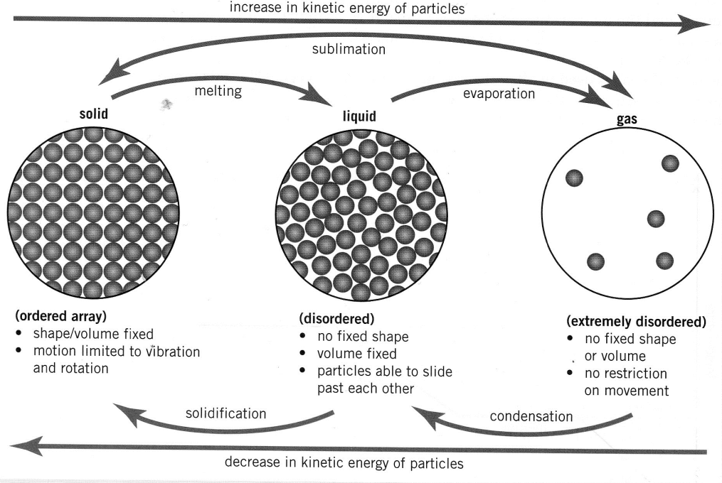

Temperature and Energy
- The temperature of a substance is a measure of the amount of internal energy the substance has.
- A substances state of matter is determined by its internal energy or temperature.
- Heating matter gives its particles more energy so they vibrate faster and move further apart. The matter will expand slightly in volume.
- If enough energy is put into the matter, the particles will have enough energy to overcome the forces holding them together and change phase.
- Cooling matter takes energy away from the particles so they vibrate more slowly and move closer together or shrinks in volume.
- When cooling takes enough energy out of the matter, the particles will move more slowly until they condense and change phase.

Questions
- Name 2 common substances that are solid at room temperature.

- Name 2 common substances that are liquid at room temperature.

- Name 2 common substances that are gas at room temperature.

- Draw the arrangement of the particles in ice, liquid water and steam.

- Describe how the particles are moving in each of the states of matter.

- What is the relationship between particle movement and temperature?

- Name the phase changes that occur when:

  - Solid turns to liquid
  - Gas turns to liquid
  - Liquid turns to gas
  - Liquid turns to solid

